WOOD/COAL BURNING FACILITY QUESTIONNAIRE
REQUIREMENTS
1. A photo of the wood/coal burning facility must be submitted with this Questionnaire.
2. Questionnaire and photo must be submitted with application for insurance.
3. Woodstove must be inspected and questionnaire signed by a licensed contractor or member of local fire department when facility is NOT factory installed or commercially installed by appliance distributor or licensed expert.
STOVE INFORMATION
TYPE | Radiant Circulating Franklin Other (specify):
MAKE/NAME | By: U.L. Approved? Yes No
USE | Primary Heat Auxiliary Heat Cooking Other (specify):
INSTALLED | By: Date:
FLOOR PROTECTION | Asbestos Millboard Covered with Metal Metal Stone/Brick Other (specify below)
WALL PROTECTION | Asbestos Millboard Covered with Metal Metal Asb. Millbrd Other (specify below)
CHIMNEY &  STOVE PIPES | CHIMNEY TYPE: Factory Masonry Other (describe):
 | How often checked for creosote build-up?
 | Date Last Cleaned: By Whom?
Does vent pass through a combustible partition? Yes No
If yes, is protection thimble or sleeve used? Yes No
Does pipe vent pass directly through the roof? Yes No
Are any other heating units vented to chimney? Yes No
(Describe below.)
Is stove vent system equipped with heat reclaiming unit or flue radiator? Yes No
CLEARANCES
1. Side of unit to nearest wall inches.  2. Rear of unit to wall inches.  3. Top of stovepipe to ceiling inches.  4. Bottom of unit to floor inches.  5. Front of unit to front edge of floor protection inches.  6. Size of stovepipe used inches.  7. Size of thimble or roof joist shield inches.  Do these distances comply with the manufacturer’s standards? Yes No |  |  | 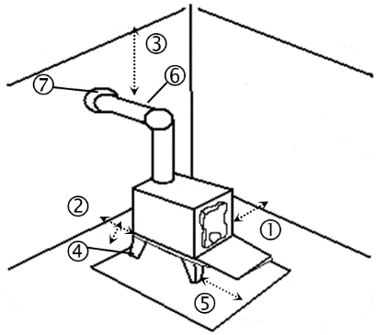
MISCELLANEOUS
FUEL |  | Wood Coal Other (specify):
PREVENTION |  | Fire Extinguisher in Room? Yes No Smoke Alarm? Yes No
ADDITIONAL REMARKS
Inspector Signature: Date Inspected:
PHOTO MUST BE ATTACHED

